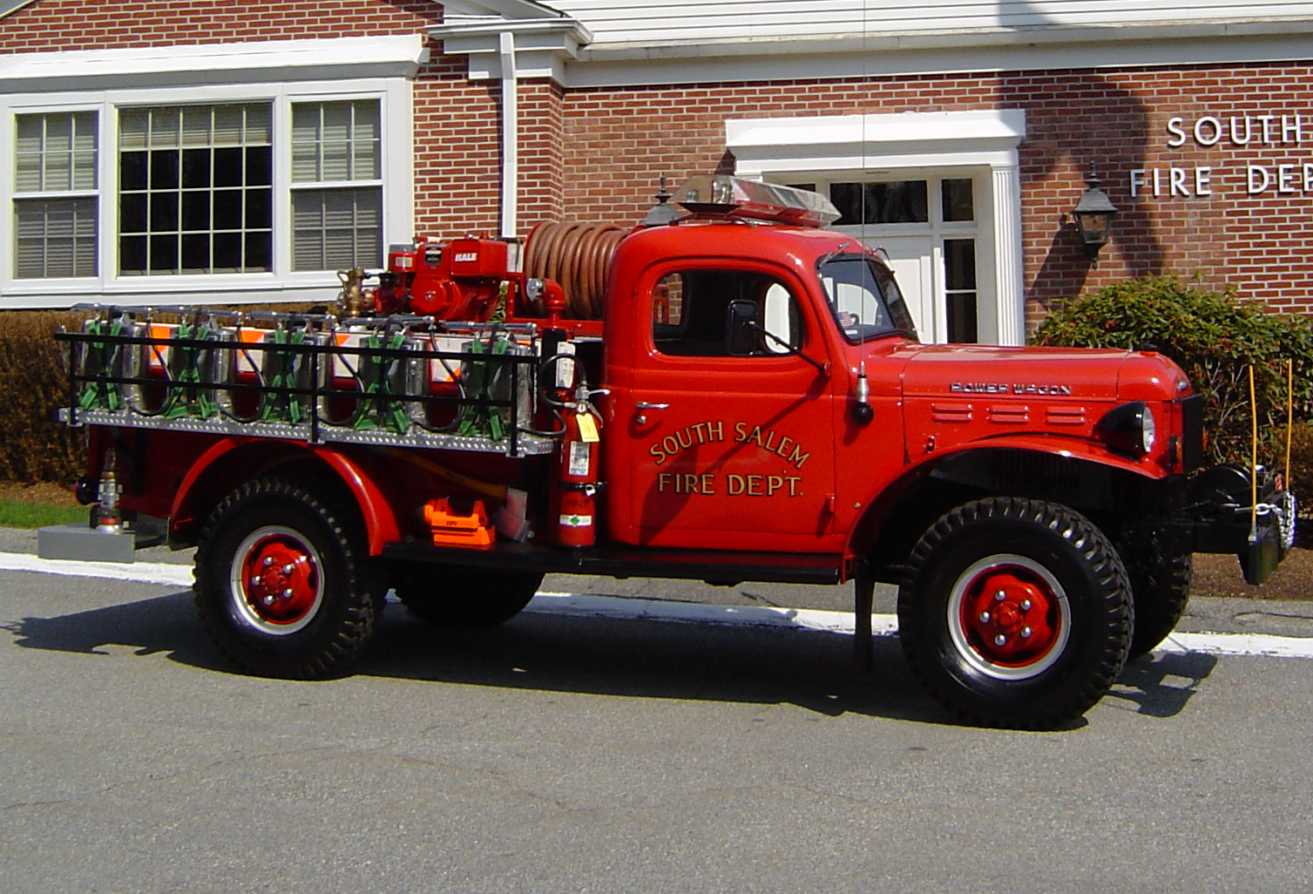
BID FORM

South Salem Fire District accepting bids for sale:
1967 Dodge Power Wagon
WM300 Military 4 Wheel Drive w\8' Body

Minimum Reserve Bid Price of $40,000

All bidders must submit their firm bid quotation in writing on this bid form. All bids must be received by 7:00 PM EST – Tuesday, February, 16 2021. Bid offerings received in a format, or upon a form other than the specified form will be considered for rejection. The South Salem Fire District reserves the right to accept, or reject any or all bids.

Bids must be submitted in a sealed envelope, and clearly marked “Vehicle Bid Dodge Power Wagon”. Bids may be hand delivered or mailed.

“Dodge Power Wagon”.
South Salem Fire District
P.O. Box 51
South Salem, NY 10590

_____________________________________________________________ bids the stated amount for
(Bidder’s Name)
the purchase of one 1967 Dodge Power Wagon as herein described and outlined in the following Conditions of Sale.

If hand delivered to Fire District Office, (1190 Route 35), It is the responsibility of the Bidder to make sure that the Name of Bidder and the Bid is clearly identifiable, and received by either the District Property Manager or District Secretary prior to the 7PM Bid time on February 16th, 2021.

Email addresses: Property Manager- firehat@optonline.net
District Secretary- secssfiredist@optonline.net

Picture of vehicle available on South Salem Fire Department website: www.southsalemfire.com

Point of Contact Information

South Salem Fire District
District Property Manager
Address: 1190 Route 35, PO Box 51
Phone: 914-763-3706 Fax: 914-763-8861
City: South Salem State: New York
Zip: 10590

Features:
Engine: Six Cylinder
Fire Pump: Hale 11 HP
Tank: 200 Gallons
10,000 lbs Front Winch

CONDITIONS OF SALE

1. The specified fire apparatus, as listed in this sale offering will be sold by competitive bid by the South Salem Fire District. The apparatus will be sold with the listed equipment.

2 Radio communication equipment, excluding fixed antennas, may have been removed and not offered for sale.

3. The fire apparatus and equipment listed in this sale offering is sold on an “AS IS - WHERE IS” basis with no sale conditions, written, verbal, or implied warranties.

4. Should the successful high bid award not be made to a fire department, fire apparatus collector, or fire apparatus dealer, the South Salem Fire District reserves the right, upon sale of the apparatus, and prior to sale settlement and delivery to remove all markings and identifications indicating the apparatus as being owned or operated by the South Salem Fire Department.

5. Bidders are encouraged to inspect the apparatus that is being offered for sale. For further information on the sale offering and to make an inspection appointment, contact the District Property Manager South Salem Fire District, 1190 Route 35, South Salem, NY; Phone: 914-763-3706. 7:00 AM-1:00PM EST / Monday thru Friday, email: firehat@optonline.net

Bid Offering for Dodge Power Wagon $_______________

BIDDER NAME_______________________________________________________________
MAILING ADDRESS___________________________________________________________
CITY / STATE / ZIP____________________________________________________________
CONTACT PERSON____________________________________________________________
CONTACT PHONE NUMBER_____________________________________________________
SIGNATURE AND TITLE OF AUTHORIZED BID AGENT:
________________________________________________ _________________________
(Agent Name & Title) (Date)

